

MELZG554 HSCD LAB ASSIGNMENT 1

HSCD of SIMPLE ISA



Submitted by,

Anand S – 2021HT80003

# Contents

Contents 2

Table of Figures 3

Table of source codes 3

Question 4

PART C: Application code to add ten numbers 5

PART A: Implement the ISA model in plain C and run the application code in PART C 6

PART B: Implement the ISA as timing accurate HW model 11

Architecture of the simple_isa CPU (simple_cpu) 11

Implementing systemVerilog design for accurate timing 11

Simulation result 13

SystemC code for simple_cpu hardware 14

Simulation result 29

APPENDIX 31

SystemVerilog code for the HDL design 31

# Table of Figures

Figure 1 Application code to add 10 numbers 5

Figure 2 C code for the simple ISA 8

Figure 3 Execution log of the C model output 10

Figure 4 High level arch of the simple_isa CPU 11

Figure 5 Snapshot of simple_instr_mem module with the application SW loaded 12

Figure 6 PC incrementing logic with an additional PC watchdog code added 13

Figure 7 Final result obtained after running sim in ModelSim. 14

Figure 8 Tree graph of the hierarchies within the design 15

Figure 9 Diagrammatic representation of the hardware blocks in simple_cpu 16

Figure 10 Waveform (part 1) of the systemC design of simple_cpu 29

Figure 11 Waveform (part 2) of the systemC design of simple_cpu 29

Figure 12 run.do file for the systemC simulation in modelsim 30

# Table of source codes

Code 1 systemC code for simple_alu 17

Code 2 systemC code for the data memory 18

Code 3 systemC code for instruction memory 19

Code 4 systemC code for pc update logic 21

Code 5 systemC code for the phase counter logic 21

Code 6 systemC code for the register file block 22

Code 7 code for decode and execution logic 25

Code 8 code for simple_cpu top-level glue block 27

Code 9 systemC code for the header file of simple_cpu in c++ for the sc_foreign_module simple_cpu 27

Code 10 systemC code for the simple_tb testbench module 28

Code 11 SV code for ALU of the simple_cpu 31

Code 12 SV code for simple_dmem: The 8x256 data memory 32

Code 13 SV code for the instruction memory, with application SW of PartC loaded 32

Code 14 SV code for the PC register and incrementing logic 33

Code 15 SV code for the phase incrementor part of the FSM 34

Code 16 SV code for the register file hardware 35

Code 17 SV code for the instruction decode and control logic 37

Code 18 SV code for the top-level module for the simple_cpu 39

Code 19 SV code for the testbench 39

# Question

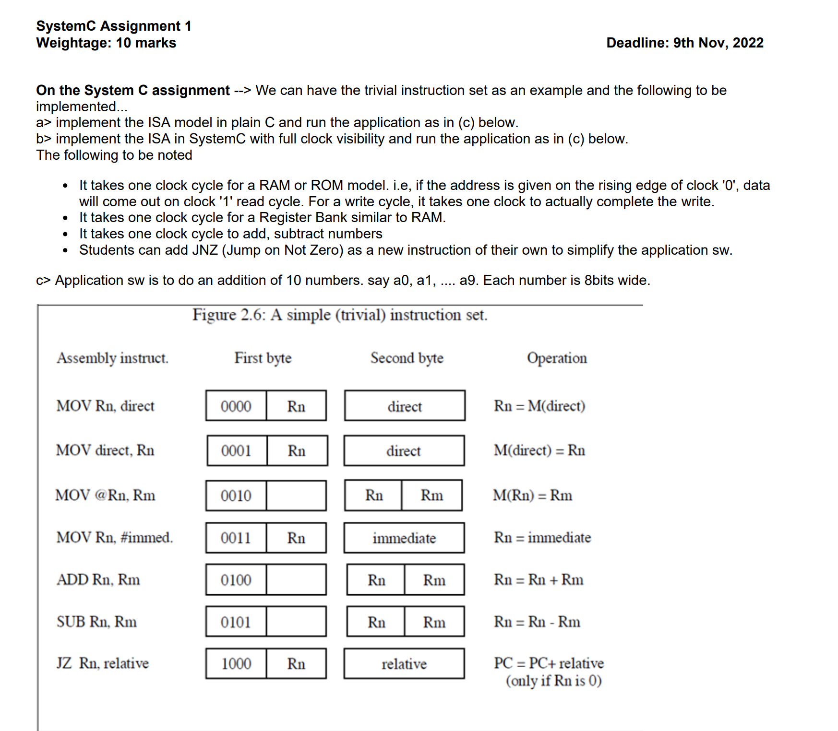

# PART C: Application code to add ten numbers



Figure 1 Application code to add 10 numbers

The SW adds 10 numbers 0, 1, 2, 3, … 9 to get a sum of 45 (0x2d) = 0 + 1 + 2 + 3 + 4 + 5 + 6 + 7 + 8 + 9

# PART A: Implement the ISA model in plain C and run the application code in PART C







Figure 2 C code for the simple ISA

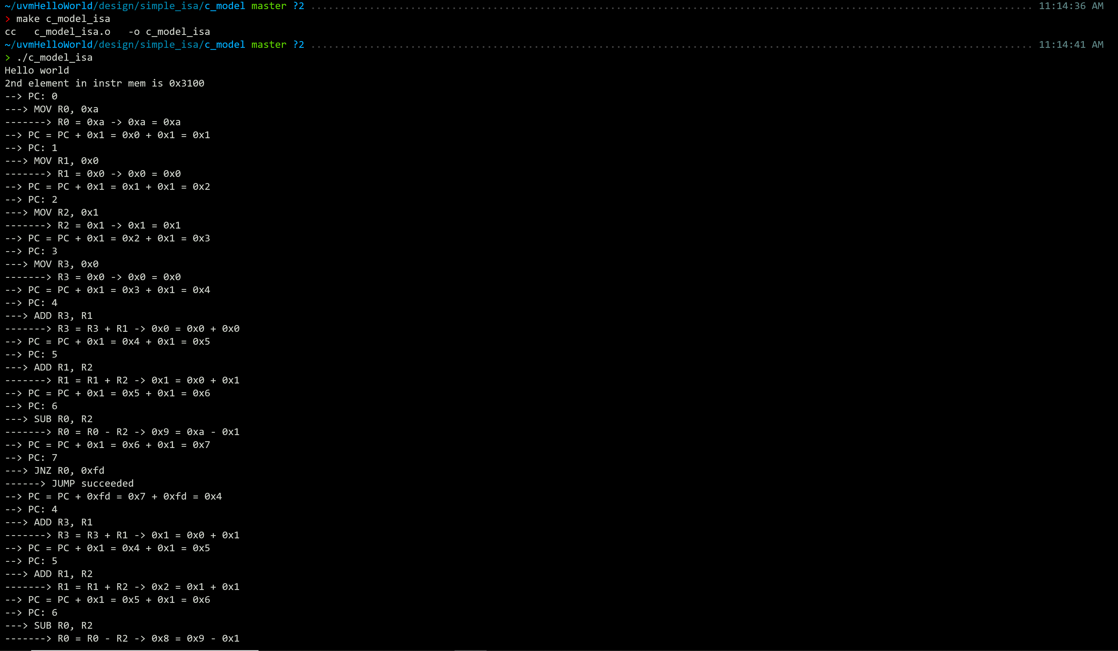

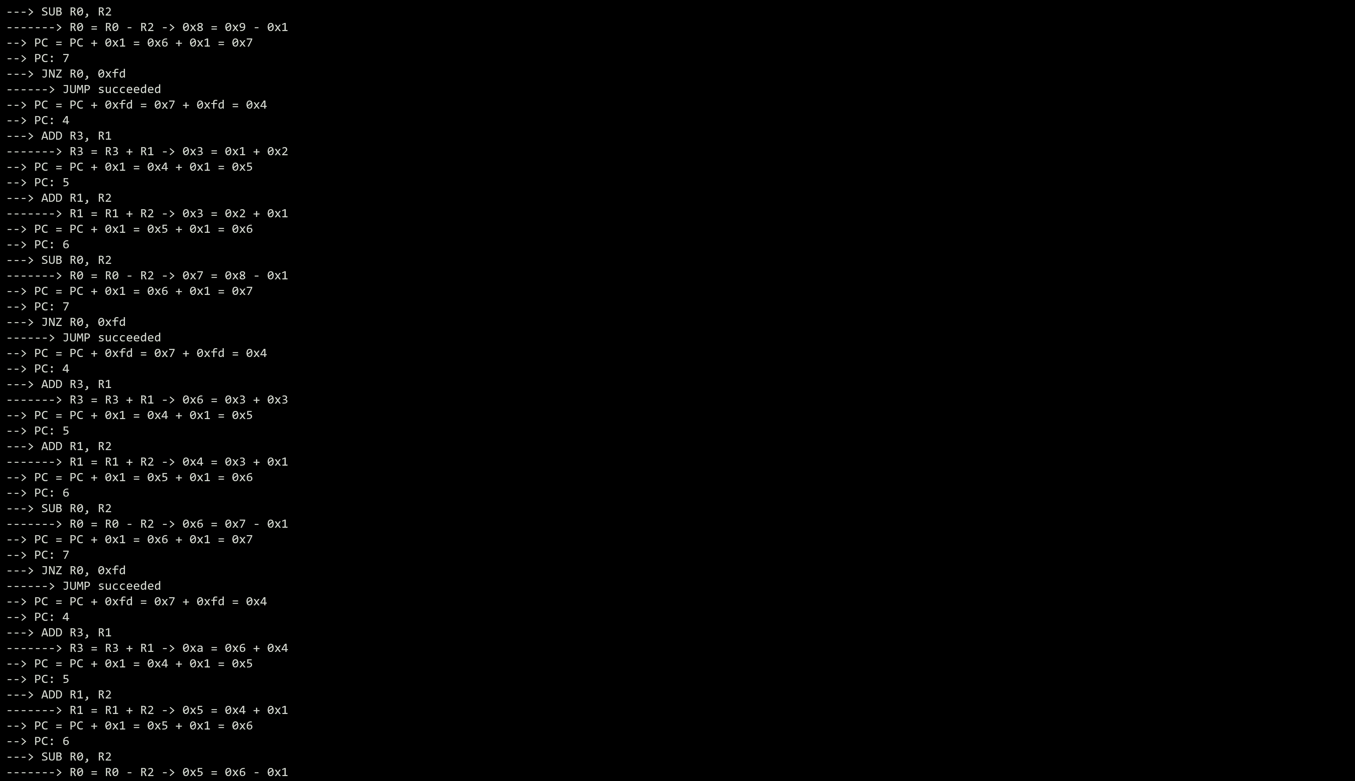

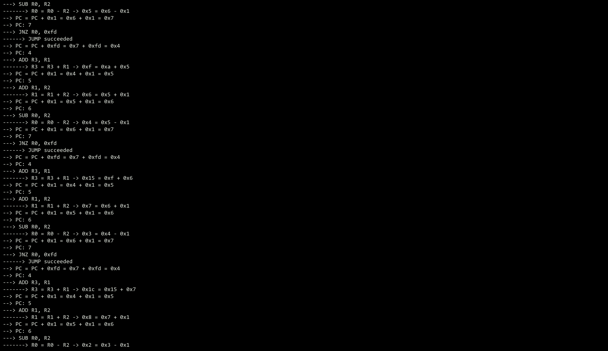

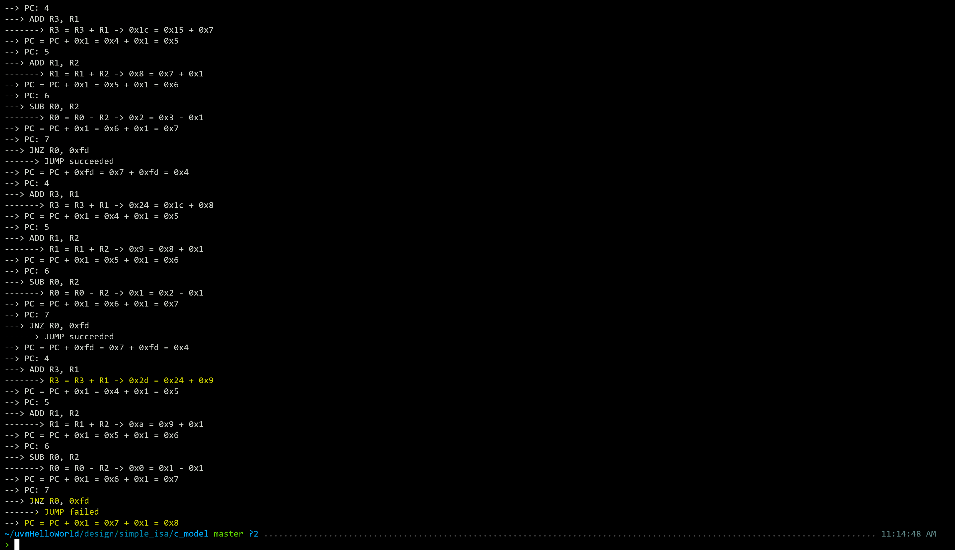

Figure 3 Execution log of the C model output

Thus the C code was executed for the application SW by coding the assembly into the instruction memory array. The execution of the code showed the final value of R3 = 8’d45 = 8’h2d, which is the expected output. Thus the execution was verified.

# PART B: Implement the ISA as timing accurate HW model

## Architecture of the simple_isa CPU (simple_cpu)

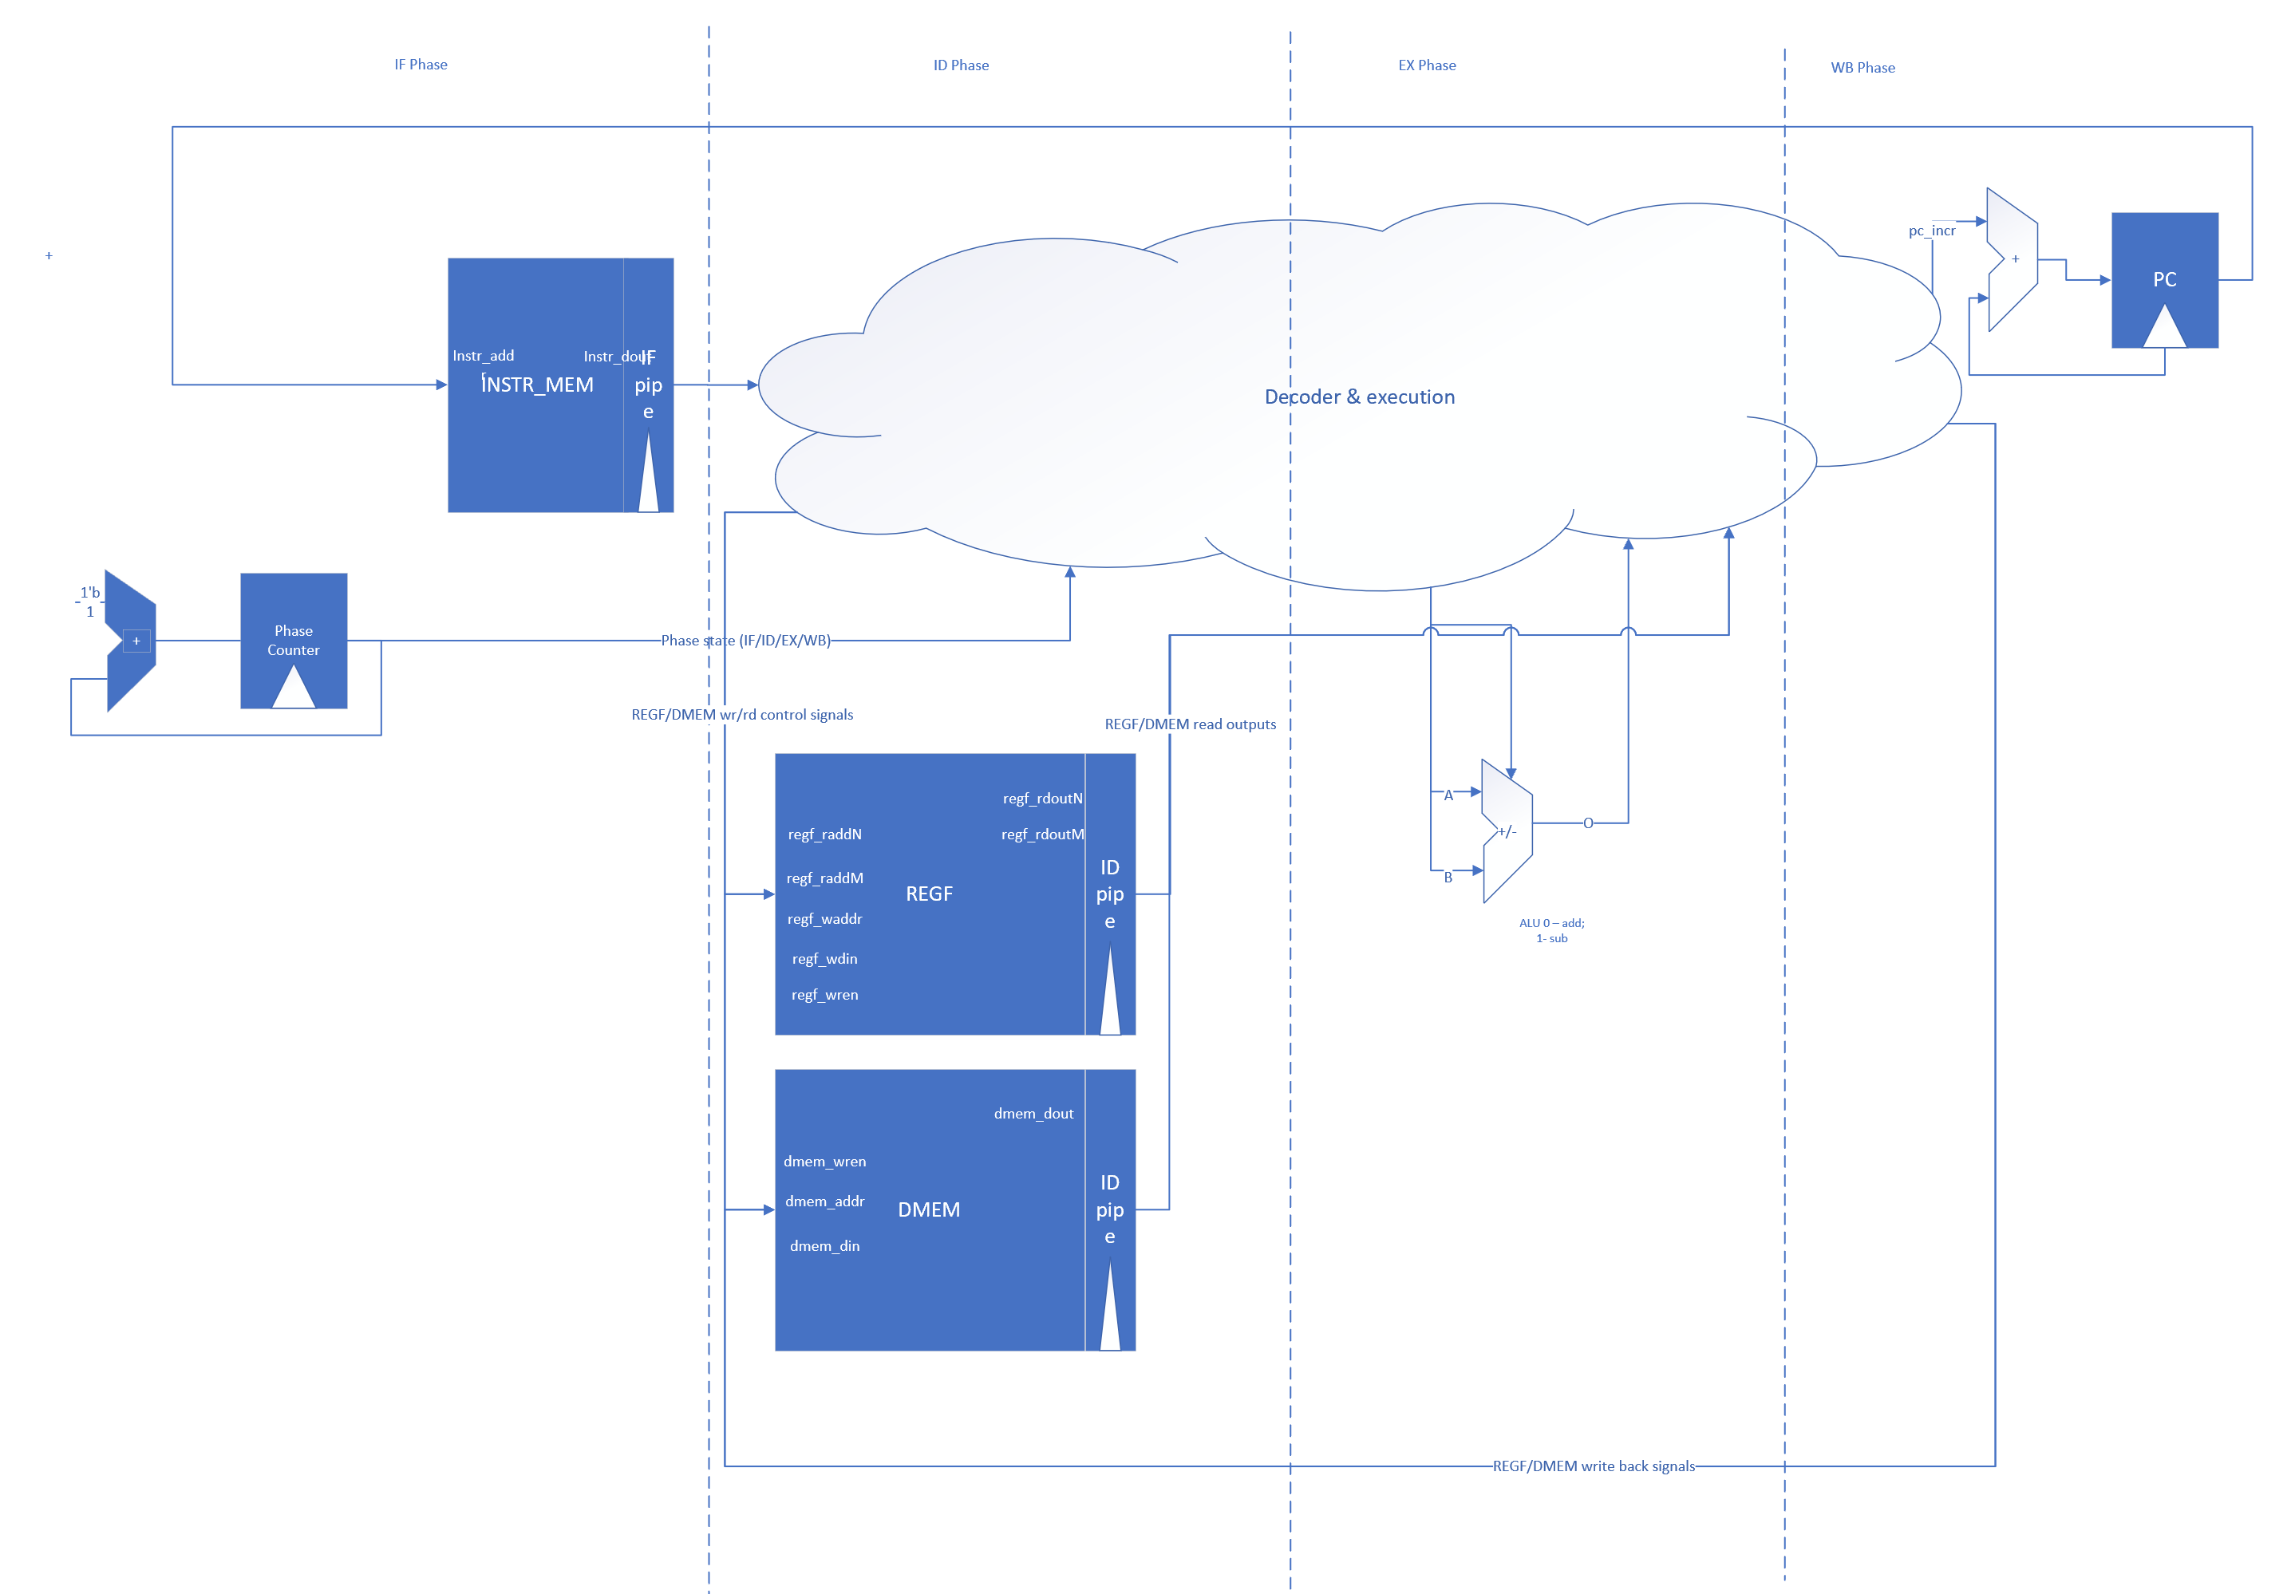

Figure 4 High level arch of the simple_isa CPU

The CPU is a 4 phase CPU with the phases IF (Instr Fetch), ID (Instr Decode), EX (Instr Execute), WB (Result Write Back). A dedicated Phase counter updates it’s count every clock cycle, once out of reset.

The decode_ex combinational logic decides how to drive the H/W resources (REGF_MEM, DMEM, ALU)

During each phase for each of the implemented opcodes.

## Implementing systemVerilog design for accurate timing

For trial and ease of implementation later-on with systemC, a timing accurate rough model was created for the SIMPLE-CPU design using systemVerilog. The detailed design is available in SystemVerilog code for the HDL design section.

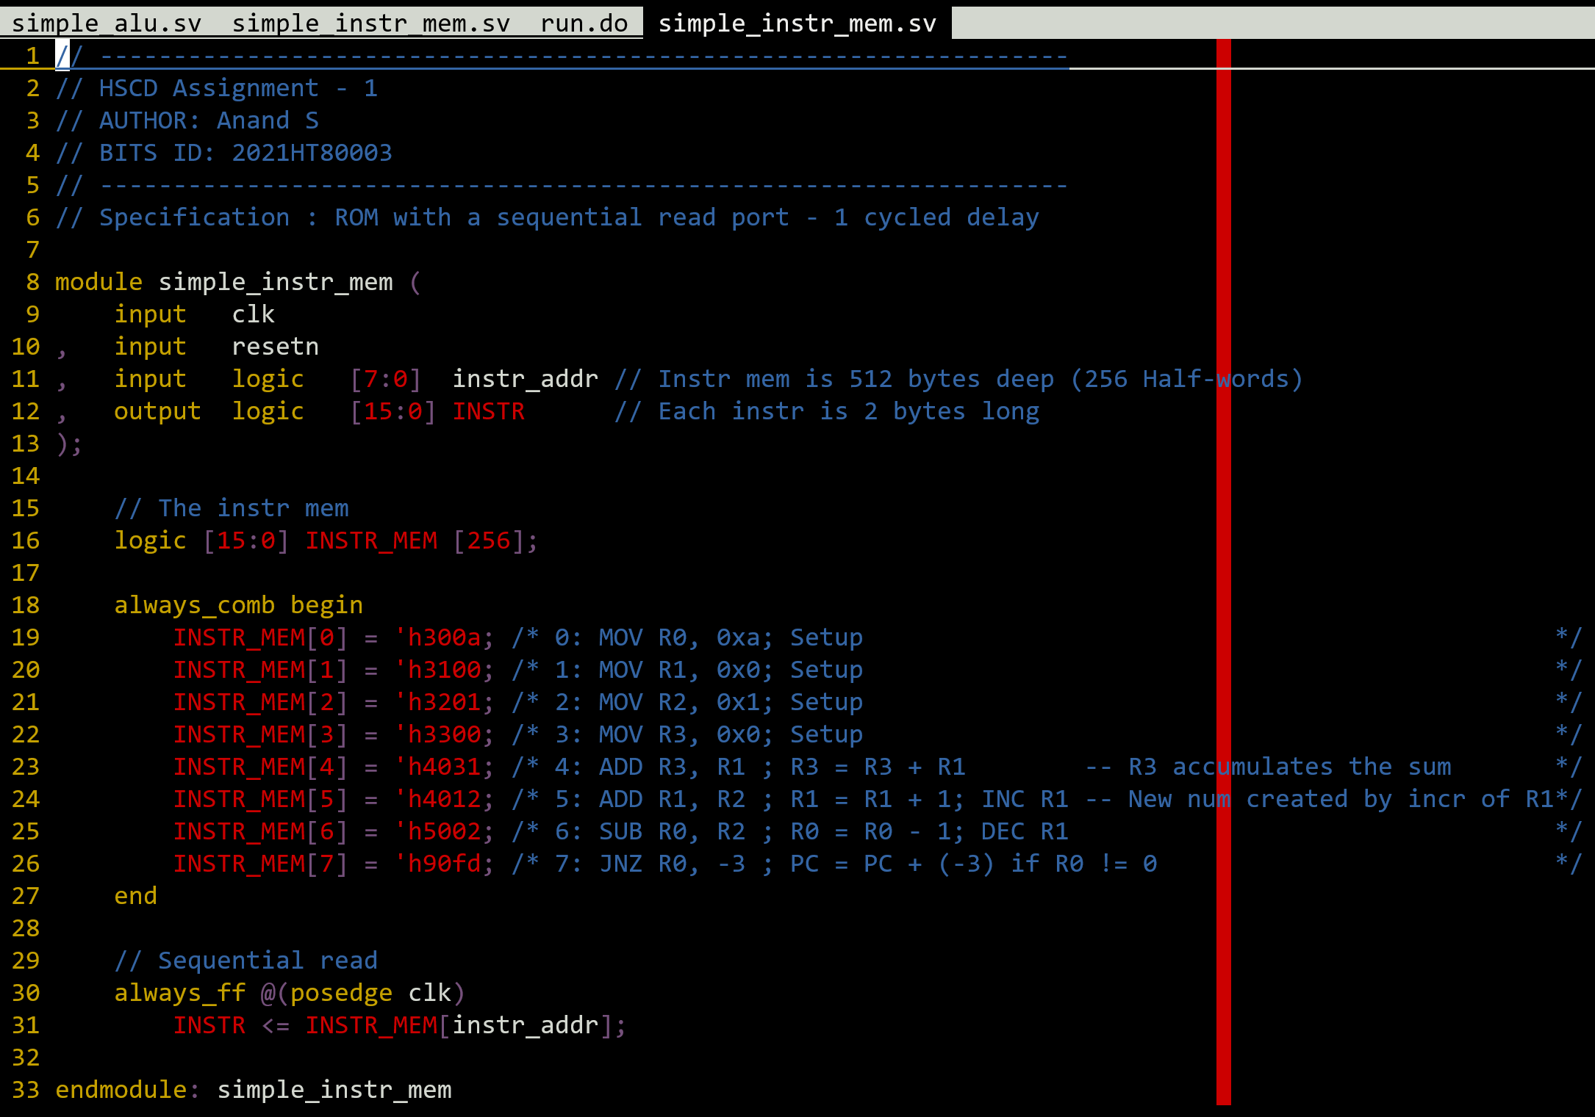

Figure 5 Snapshot of simple_instr_mem module with the application SW loaded

The PC watchdog code ensures that the simulation completes when PC reaches value ‘8’. This is beyond the application code space, so this is a safe way to test the code.

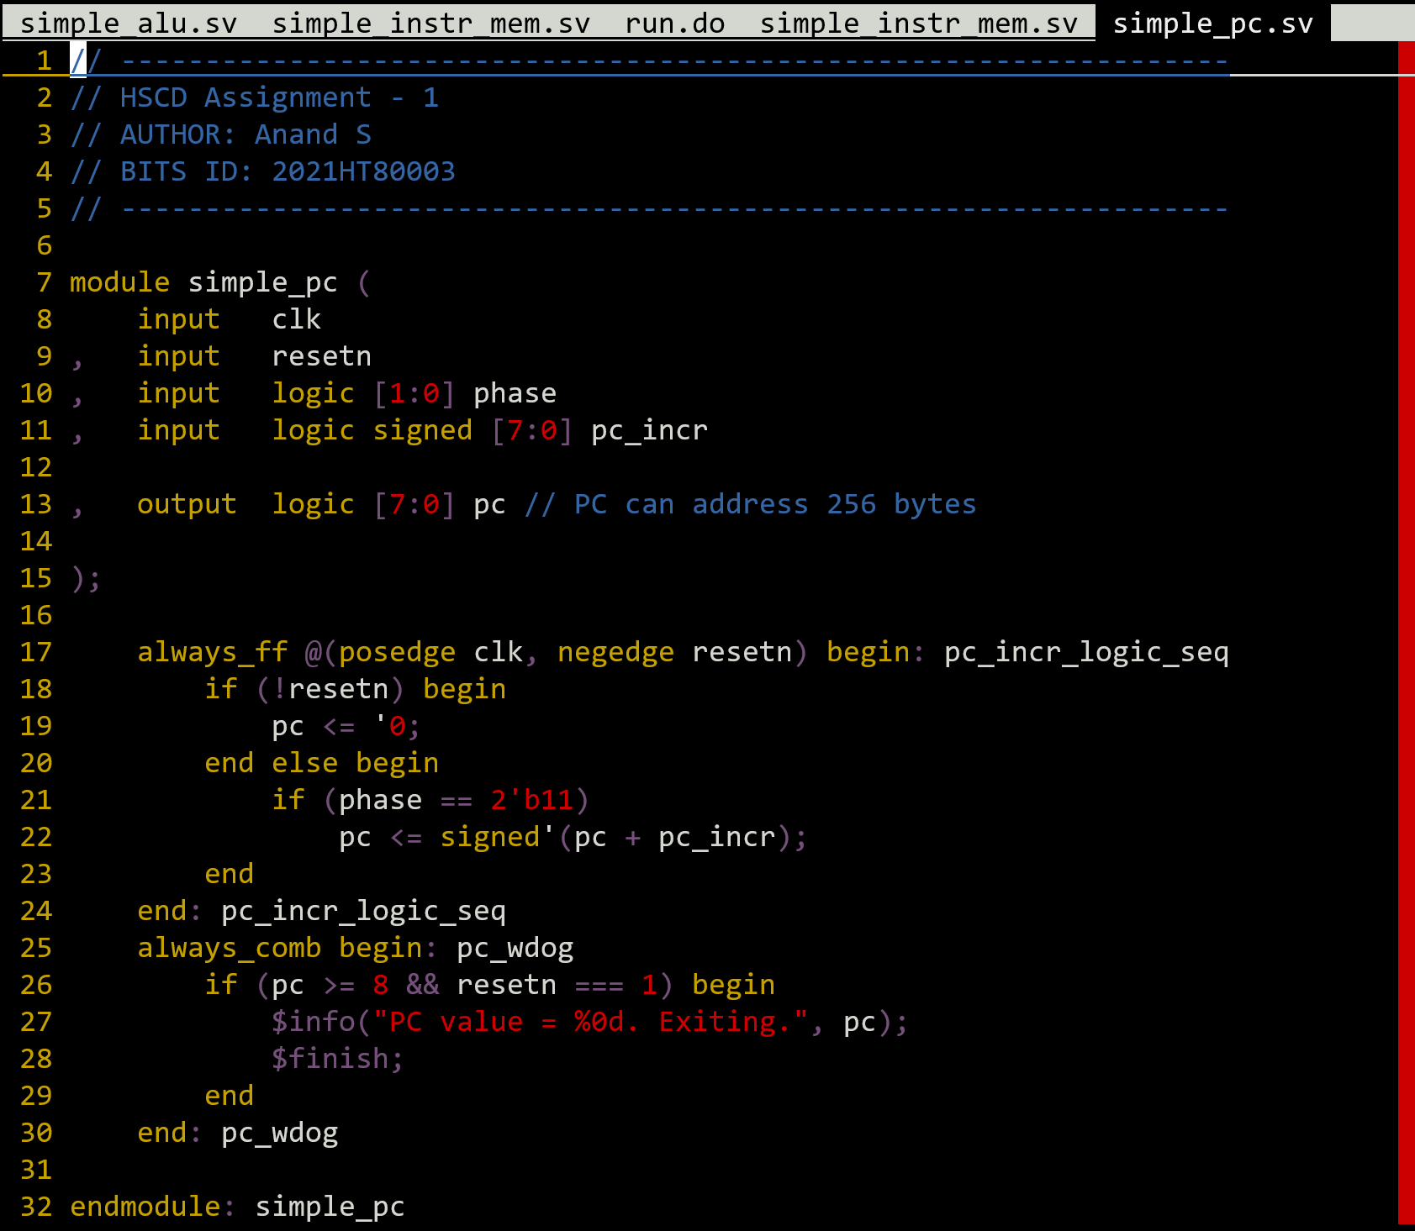

Figure 6 PC incrementing logic with an additional PC watchdog code added

Below is the obtained waveform. As shown at the bottom of the waves REGF[3] accumulates to a value of 0x2D, which is the expected result for the SW as obtained from the C model.

### Simulation result

The simulation was done by loading the SW code with the simple ISA as shown below. This will act as a reference going forward for the systemC design.

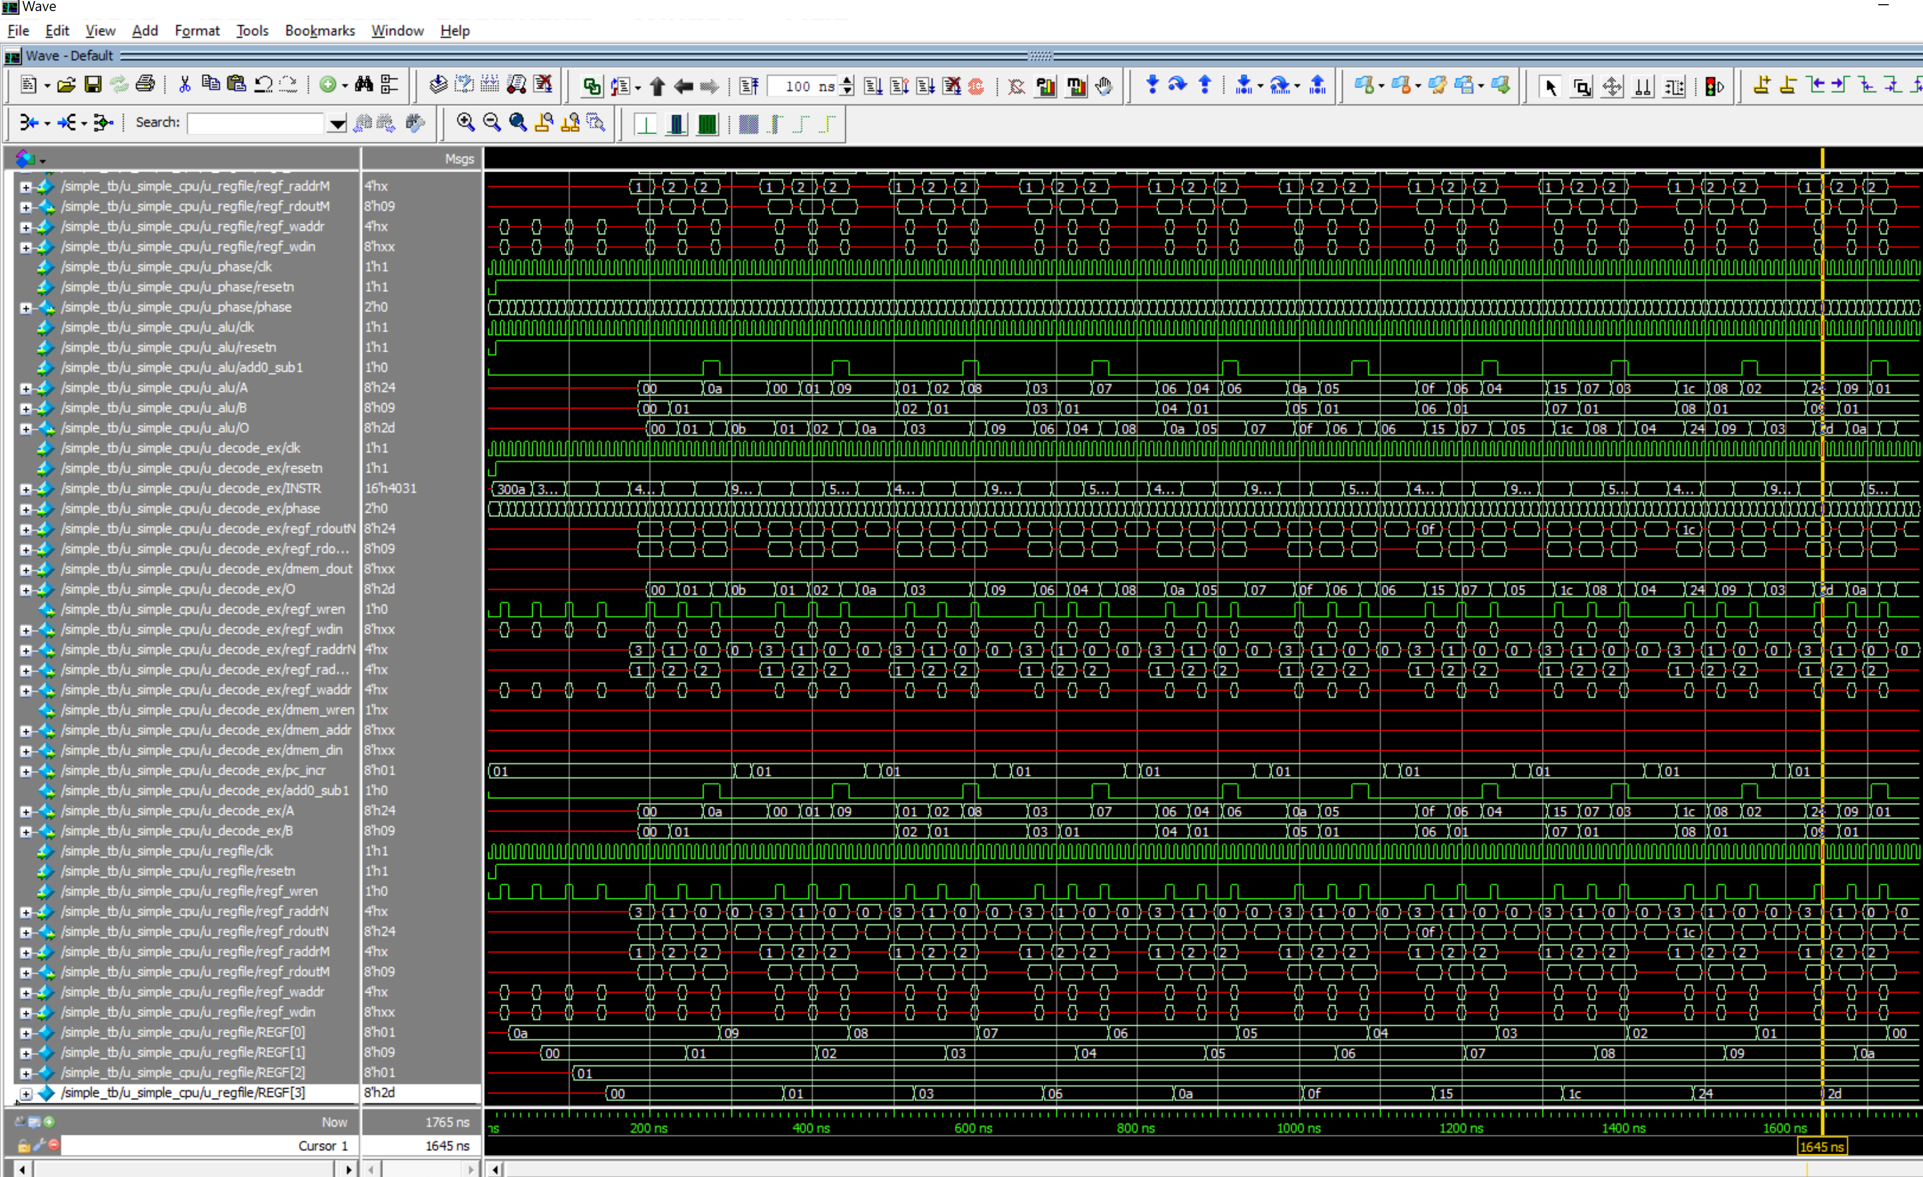

Figure 7 Final result obtained after running sim in ModelSim.

Note the highlight in the above figure.

It is clear from the waveform how the R0 register is updated to decrement in each loop, while the R1 register increments in each of the loop of the application SW.

## SystemC code for simple_cpu hardware

Implementing the design as systemC code deriving from the systemVerilog model. Below is a tree graph of the hierarchical structure of the design.

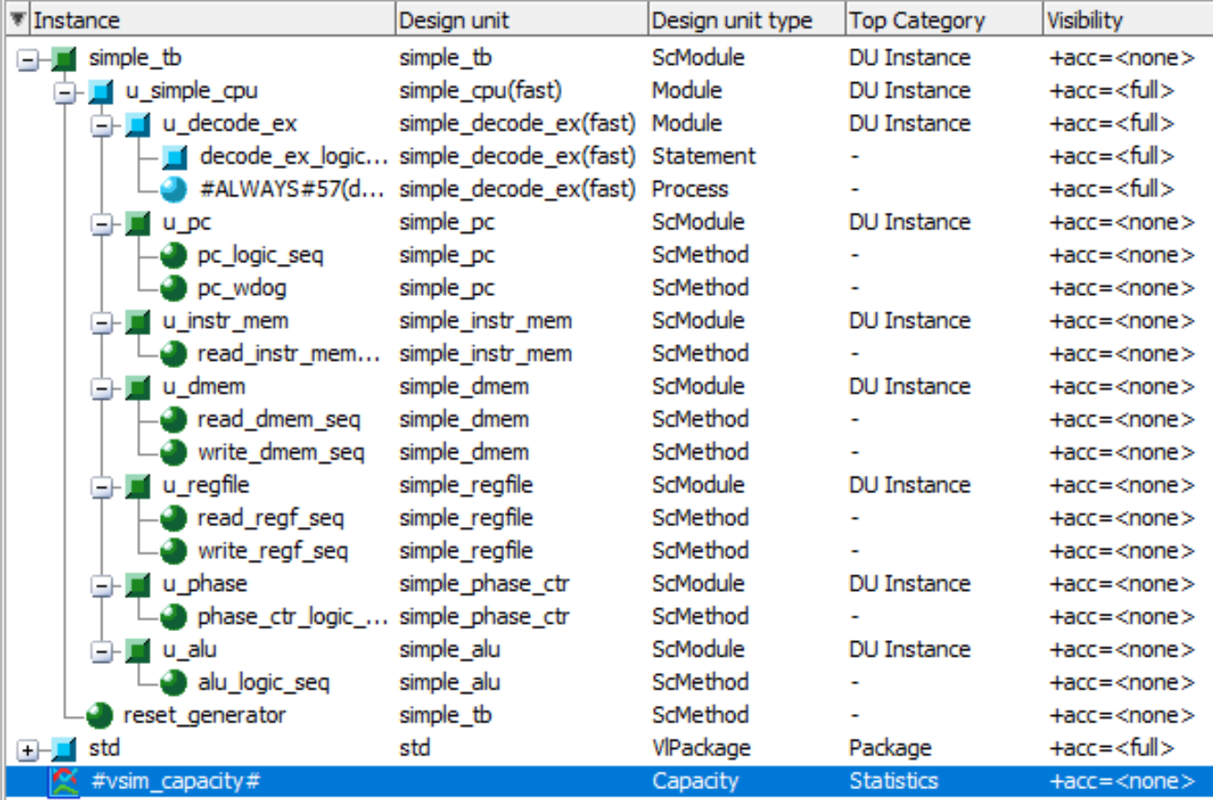

Figure 8 Tree graph of the hierarchies within the design

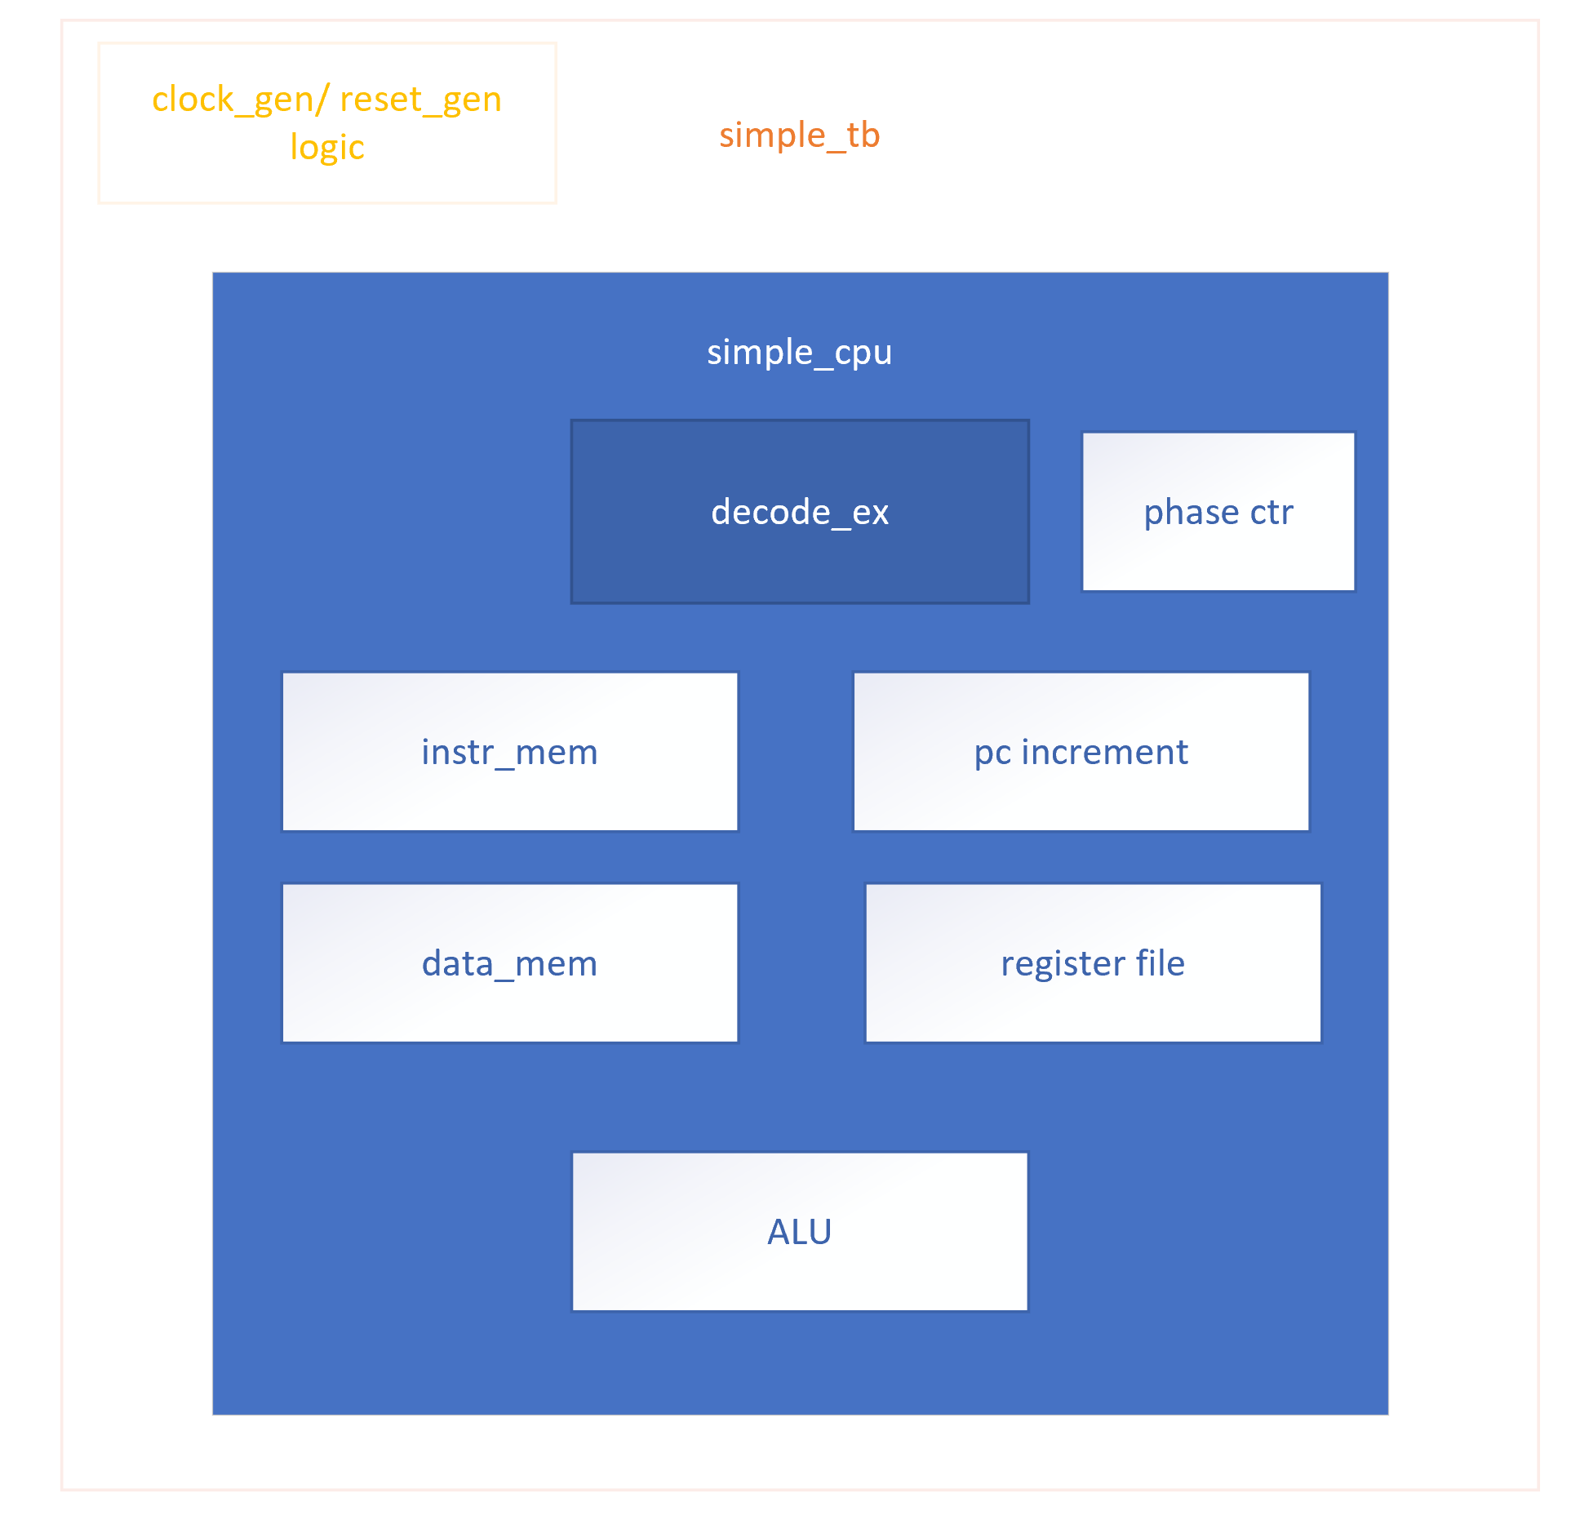

Figure 9 Diagrammatic representation of the hardware blocks in simple_cpu

Here, apart from the decode_ex and the cpu top-level, all the other modules, including the testbench are coded in systemC.

Below are the various source codes used for the systemC model of the design



Code 1 systemC code for simple_alu



Code 2 systemC code for the data memory



Code 3 systemC code for instruction memory



Code 4 systemC code for pc update logic



Code 5 systemC code for the phase counter logic



Code 6 systemC code for the register file block







Code 7 code for decode and execution logic



Code 8 code for simple_cpu top-level glue block



Code 9 systemC code for the header file of simple_cpu in c++ for the sc_foreign_module simple_cpu



Code 10 systemC code for the simple_tb testbench module

### Simulation result

The code was simulated using ModelSim SE 2019.2 version. And the behaviour of the module was found to match with that of the systemVerilog model exactly

Below are the waveforms for proof

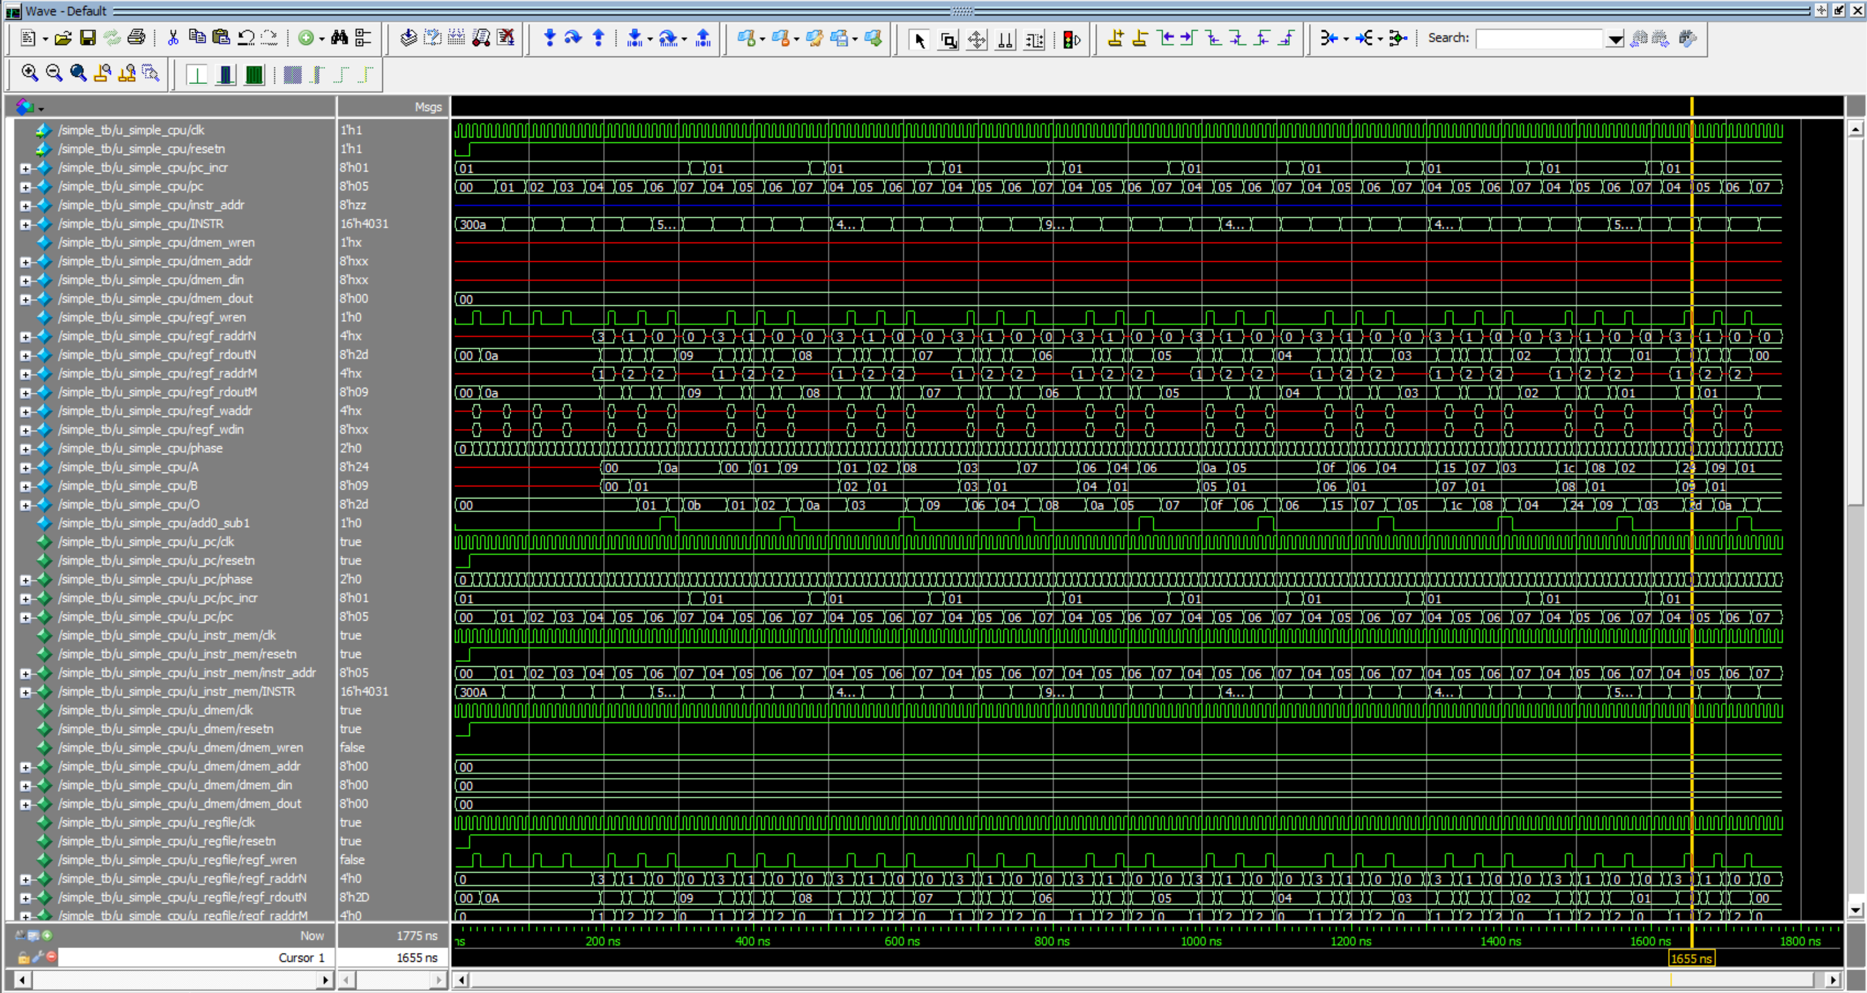

Figure 10 Waveform (part 1) of the systemC design of simple_cpu

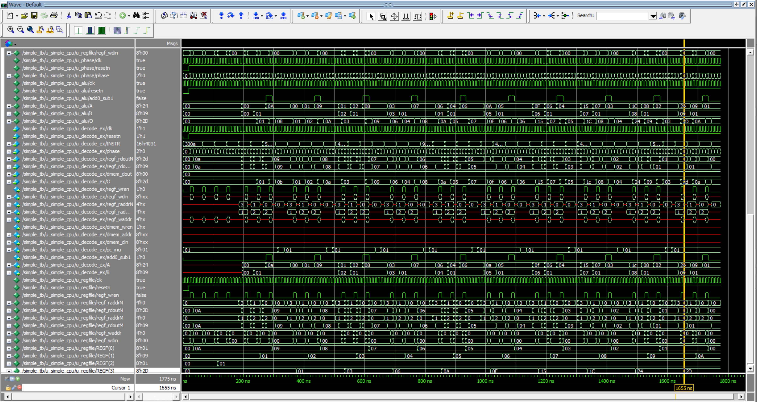

Figure 11 Waveform (part 2) of the systemC design of simple_cpu

Below is the run.do file used to simulate the code

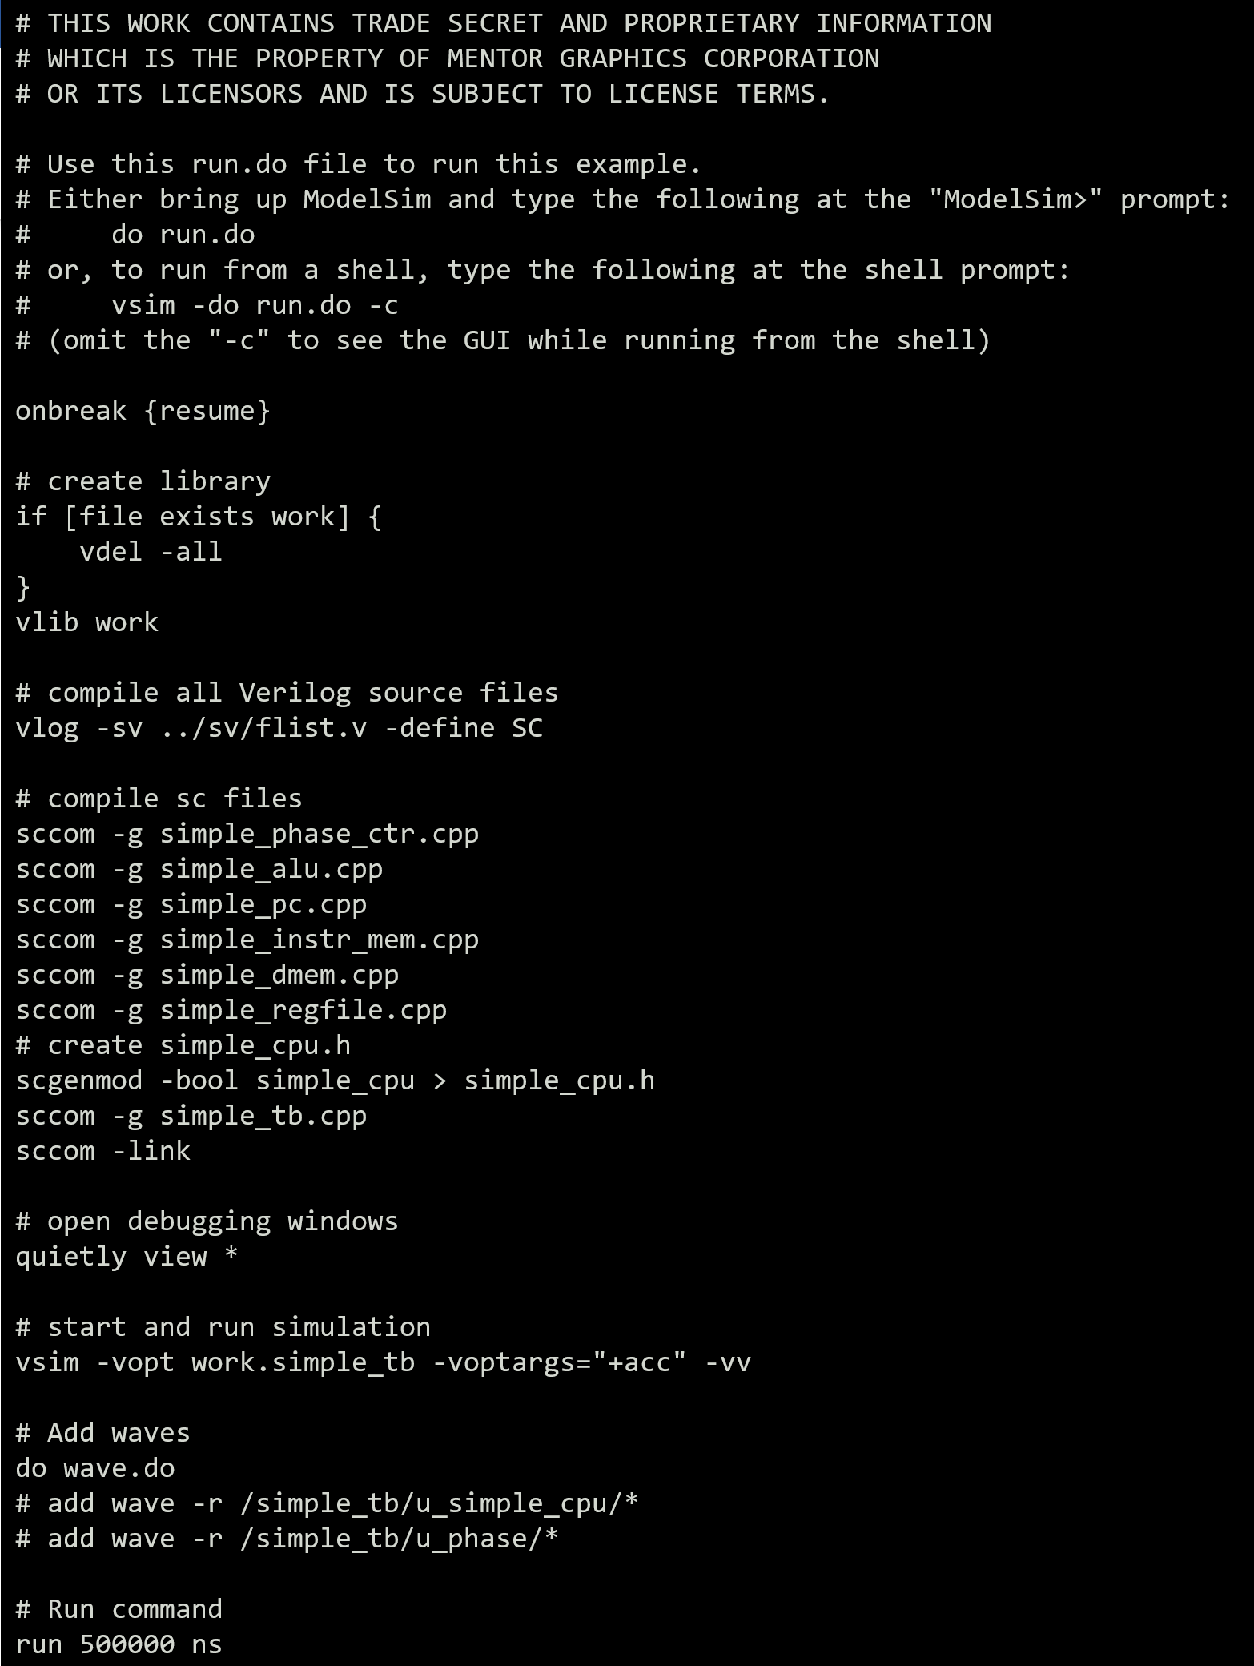

Figure 12 run.do file for the systemC simulation in modelsim

# APPENDIX

## SystemVerilog code for the HDL design



Code 11 SV code for ALU of the simple_cpu



Code 12 SV code for simple_dmem: The 8x256 data memory



Code 13 SV code for the instruction memory, with application SW of PartC loaded



Code 14 SV code for the PC register and incrementing logic



Code 15 SV code for the phase incrementor part of the FSM



Code 16 SV code for the register file hardware





Code 17 SV code for the instruction decode and control logic



Code 18 SV code for the top-level module for the simple_cpu



Code 19 SV code for the testbench

THE END.

ANAND S

2021HT80003